Deerwalk Institute of Technology

Neural Network

LAB SHEET - 2

Submitted By: Submitted To:
Sagar Giri Sarbin Sayami
Roll No: 0205
Section: A

1. Graph plot of sigmoid function through program
Sigmoid.py

import matplotlib.pyplot as plt
import math
import numpy
y = []
x = numpy.arange(-5,5,0.1)
for i in x:
val = 1/(1+math.exp(-i))
y.append(val)
plt.plot(y)
plt.show()

Output:

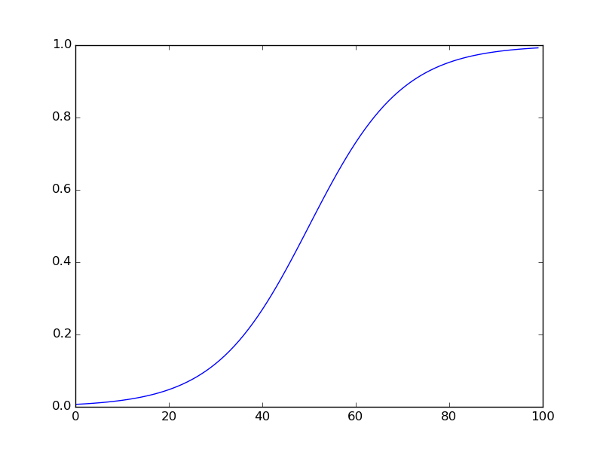

2. Visualization of Mexican Hat function

Mexicanhat.py

import matplotlib.pyplot as plt
import numpy
import math
y = []
x = numpy.arange(-5,5,0.1)
for i in x:
val = ((1-i**2)*math.exp(-i**2/2))
y.append(val)
plt.plot(y)
plt.show()

OutPut:
